
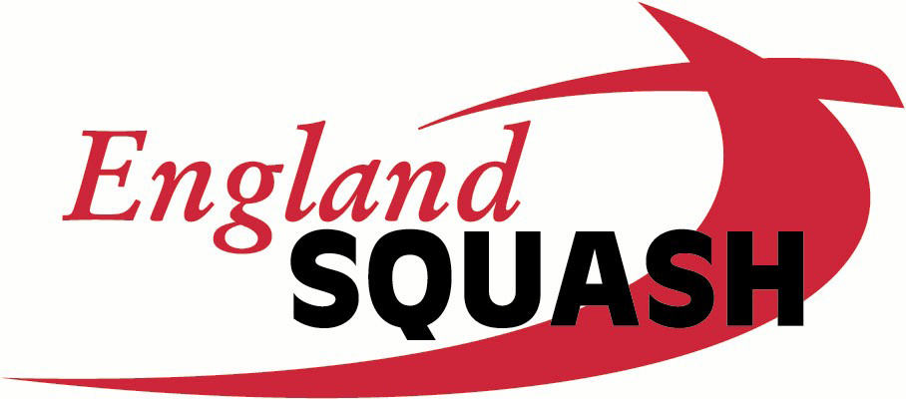
National Racketball
Championships 2008
(Singles Event)
Edgbaston Priory Club
Sir Harry’s Road, Edgbaston, Birmingham, B15 2UZ
Tel: 0121 440 2492
23, 24, 25 May 2008

FULL NAME
ADDRESS
TEL NUMBER
MOBILE NUMBER
EMAIL
COUNTY
ES MEMBER NO

I wish to enter the following events: (Please tick the relevant box)

 | MEN | WOMEN
OPEN
OVER 35
OVER 40
OVER 45 |  | 
OVER 50
OVER 55
OVER 60
OVER 65
OVER 70
Entries close: Friday, 2nd May, 2008
You are allowed to enter a maximum of two events.
If there are more than 32 Entries in any category, preliminary rounds may be
played for locally based players on Thursday 22nd May,
There will be Plate Events if sufficient entries are received.
All finals will be played on Sunday 25th May, 2008

All entries by post to
Rob Shay c/o Edgbaston Priory Club.
Together with a cheque for the correct amount made payable to R. Shay

The Entry Fee shall be £10.00 per event and must accompany this Entry Form.

Draws will be published onn www.edgbastonpriory.com in due course. For any queries please contact Rob Shay at q-m@fsbdial.co.uk or phone 07973 666 184
Times of play will be circulated to all players providing a prepaid SAE is enclosed.

I agree to abide by the Championships Regulation and the England Squash Code of Conduct.

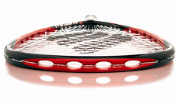
SIGNED……………………………………………… DATE……………………

